Junior Woman’s Club of Raleigh
Dobbins/Bedini-Lewis Endowed Scholarship
Application Packet

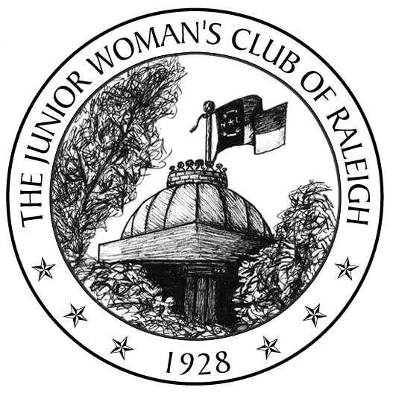About the Fund
The Junior Woman’s Club (JWC) of Raleigh is a non-profit, civic organization for women, ages 18-45, committed to promoting volunteerism, improving our community, and fostering new friendships. We award a scholarship annually from our club’s Endowment Fund. The purpose of the scholarship is to assist a returning adult student in furthering his or her education. This year the JWC of Raleigh will be awarding up to a $2,500 scholarship.

The Lynne Bedini-Lewis Endowed scholarship was established in 2004 by Ben and Peg Bedini in honor of their daughter and outgoing president, Lynne Bedini Lewis. In 2012 this scholarship was merged into the JWC Endowment fund and the JWC Dobbins/Bedini Lewis Endowed Scholarship was formed. The combining of funds was done in hopes of being able to award a larger scholarship in the future.

Eligibility Requirements
Individuals may apply to the JWC of Raleigh Endowment Fund Scholarship for tuition and fees affiliated with attendance at an institution of higher learning. The 2017 total scholarship distribution will be up to $2,500. The scholarship committee may choose to award the entire amount to one student or divide it between two students. The recipient(s) will be selected on the following criteria:
- Individual has a high regard for obtaining an education and the courage to pursue it in spite of limited financial resources and other challenging life circumstances.
- Individual demonstrates leadership, commitment to academics, a solid work ethic, involvement in extracurricular or community-based activities, and friendship towards others.
- Individual has a purpose and a plan for being a productive citizen.
- Individual demonstrates a commitment to diversity; recognizing the value of all people; regardless of religion, ethnicity, socioeconomic status or ability.
- Individual is a resident of Wake County and plans to or is attending a North Carolina school of higher education.

Required Items
- JWC of Raleigh Endowment Fund Scholarship Application Form (follows)
- JWC of Raleigh Endowment Fund Scholarship Financial Information Form (follows)
- FAFSA Student Aid Report
  - Available by filing FAFSA at www.fafsa.ed.gov
- Essay – typed (preferred, but not required), 250-500 words addressing the following prompt:
  - Describe your plans and aspirations for college and beyond. Explain what has led you to choose this path and the challenges that you expect to face along the way.
- List of Extracurricular, Community-Based Activities
  - On a single separate page, please provide a list of your extracurricular activities (clubs, sports, fine arts groups, volunteer work, scouting, hobbies, jobs, internships, etc.), including the years you participated and the number of hours per week devoted to each. Also list awards or recognitions you have received.
- High School or any higher education transcripts and/or GED, ABE or SAT scores.
- Letters of Recommendation - two (2), in sealed envelopes
  - One from a teacher
  - One from a teacher, guidance counselor, employer, pastor, supervisor, or other qualified individual
- Applicant must submit a completed application and all supporting documents to the JWC of Raleigh Endowment Fund Scholarship Committee by Saturday, April 1, 2017 to be eligible for consideration.

Our club committee will review all applications received and select finalists to interview in late April or early May. Please send your completed application and supporting materials via mail or email to:

Casandra Webb
Attn: JWC Endowment Scholarship
1101 Weston Green Loop
Cary, NC 27513
endowment@jwcraleigh.org

Sincerely,

Casandra Webb

Casandra Webb
JWC of Raleigh Endowment Chairman
Junior Woman’s Club of Raleigh
Dobbins/Bedini-Lewis Endowed Scholarship
Application Form

I am applying for the JWC of Raleigh Endowment Fund Scholarship.

Name
Last First Middle Preferred Name

Mailing Address ____________________________________

County of Residence Date of Birth _______

Email Home Telephone

Gender Marital Status

Do you have children: Yes No. If yes, please list ages: _________________________________________

Do you have any other dependents: Yes No

Have you ever been convicted of a misdemeanor or felony? Yes No. If yes, please explain. __________
__________________________________________________________________________________________

School/College you plan to attend this fall:

Type of School: 2 year 4 year Graduate Other:

Enrollment Status: Full Time (12+ hours) Part Time (6-11 hours) Other:

Please name any other scholarships for which you have been awarded? ________________________________
__________________________________________________________________________________________

If you are awarded the JWC of Raleigh Endowment Scholarship, how will the balance of your college expenses be financed? ______________________________________________________________________________

I certify that the information provided in this application packet is complete and accurate to the best of my knowledge. I understand that falsification of information will result in termination of any scholarship granted. I understand that incomplete applications may not be considered. I certify that I have read the instructions and will comply with all requests for documentation of financial need and academic status. Should I receive a scholarship, I will notify the JWC of Raleigh of any change of plans, and the JWC of Raleigh may use my name and likeness in publicity materials relating to the scholarship.

I understand that JWC of Raleigh scholarships may only be used towards the published cost of attendance at accredited US institutions of higher learning.

Signature of Applicant Date

Junior Woman’s Club of Raleigh
Dobbins/Bedini-Lewis Endowed Scholarship
Financial Information Form

PERSONAL INFORMATION

Are you currently employed? Yes No

Employer’s name, address and phone number: __________________________________________________
________________________________________________________________________________________

Occupation: __________________________ Annual gross income: $___________________________

Do you receive any government assistance? Yes No

Have you informed the financial aid office of your need for financial assistance? Yes No

FINANCIAL INFORMATION *

Use your Federal Income Tax Return (IRS Form 1040) to determine adjusted gross income figures.

Total number in household that head(s) of household will support in coming school year
Total number in household in a college degree/certificate program in coming school year
Head(s) of household’s total adjusted gross income for prior tax year $
Head(s) of household’s total cash assets (cash, checking, savings, and/or investments,
excluding retirement accounts and primary home equity) $
Student’s adjusted gross income for prior tax year (if not head of household) $
Student’s total cash assets (if not head of household) $

If you wish, you may include a Supplementary Financial Statement explaining circumstances impacting financial need that are not apparent from the above financial information, for example, contributions expected/not expected from a non-custodial parent, educational expenses already incurred for older siblings, medical expenses, daycare, etc.

In addition to the information above, you must include a copy of your Student Aid Report (SAR), obtained by filing the Free Application for Federal Student Aid (FAFSA), before any potential funding is approved. It is your responsibility to complete the FAFSA application (available online at www.fafsa.ed.gov) and to provide a copy of your SAR to us as documentation of financial need. **If you cannot obtain an SAR before the due date for your scholarship, please consult the scholarship administrator for further instruction. **

I certify that the information provided above is complete and accurate to the best of my knowledge.

Signature of Applicant Date

