Junior Woman’s Club of Raleigh
Dobbins/Bedini-Lewis Endowed Scholarship
Application Packet

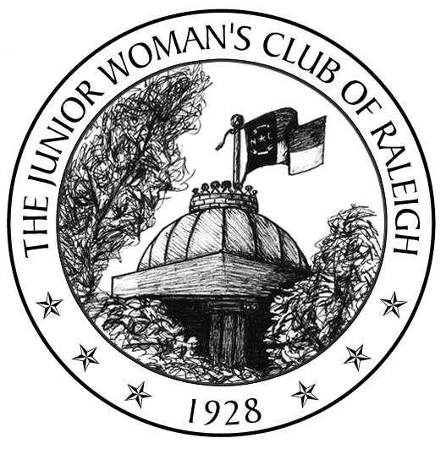About the Fund
The Junior Woman’s Club (JWC) of Raleigh is a non-profit, civic organization for women, ages 18-45, committed to promoting volunteerism, improving our community, and fostering new friendships. We award a scholarship annually from our club’s Endowment Fund. The purpose of the scholarship is to assist a returning adult student in furthering his or her education. This year the JWC of Raleigh will be awarding up to a $2,000 scholarship.

The Lynne Bedini-Lewis Endowed scholarship was established in 2004 by Ben and Peg Bedini in honor of their daughter and outgoing president, Lynne Bedini Lewis. In 2012 this scholarship was merged into the JWC Endowment fund and the JWC Dobbins/Bedini Lewis Endowed Scholarship was formed. The combining of funds was done in hopes of being able to award a larger scholarship in the future.

Eligibility Requirements
Individuals may apply to the JWC of Raleigh Endowment Fund Scholarship for tuition and fees affiliated with attendance at an institution of higher learning. The 2022 total scholarship distribution will be up to $2,000. The scholarship committee may choose to award the entire amount to one student or divide it between two students. The recipient(s) will be selected on the following criteria:
- Individual has a high regard for obtaining an education and the courage to pursue it in spite of limited financial resources and other challenging life circumstances.
- Individual demonstrates leadership, commitment to academics, a solid work ethic, involvement in extracurricular or community-based activities, and friendship towards others.
- Individual has a purpose and a plan for being a productive citizen.
- Individual demonstrates a commitment to diversity; recognizing the value of all people; regardless of religion, ethnicity, socioeconomic status or ability.
- Individual is a resident of Wake County and plans to or is attending a North Carolina school of higher education.

Required Items
- JWC of Raleigh Endowment Fund Scholarship Application Form (follows)
- JWC of Raleigh Endowment Fund Scholarship Financial Information Form (follows)
- Essay – typed (preferred, but not required), 250-500 words addressing the following prompt:
  - Describe your plans and aspirations for college and beyond. Explain what has led you to choose this path and the challenges that you expect to face along the way.
- List of Extracurricular, Community-Based Activities
  - On a single separate page, please provide a list of your extracurricular activities (clubs, sports, fine arts groups, volunteer work, scouting, hobbies, jobs, internships, etc.), including the years you participated and the number of hours per week devoted to each. Also list awards or recognitions you have received.
- Letter of recommendation from a teacher, guidance counselor, employer, pastor, supervisor, or other qualified individual.
  - Must be signed and on letterhead
- Applicant must submit a completed application and all supporting documents to the JWC of Raleigh Endowment Fund Scholarship Committee by Friday, April 22, 2022 to be eligible for consideration.

Our club committee will review all applications received and select finalists for possible interviews. Please send your completed application and supporting materials via mail or email to:

Christy Frisbee
Attn: JWC Endowment Scholarship
8308 Yucca Trl.
Raleigh, NC 2725
endowment@jwcraleigh.org

Sincerely,

Christy Frisbee
JWC of Raleigh Endowment Chair
Junior Woman’s Club of Raleigh
Dobbins/Bedini-Lewis Endowed Scholarship
Application Form

Name
Last First Middle Preferred Name
Mailing Address ____________________________________
County of Residence Date of Birth _______
Email Home Telephone
Gender Marital Status
Do you have children: Yes No. If yes, please list ages: ________________________________________________
Do you have any other dependents: Yes No
Have you ever been convicted of a misdemeanor or felony? Yes No. If yes, please explain. __________________
School/College you plan to attend this fall:
Type of School: 2 year 4 year Graduate Other:
Enrollment Status: Full Time (12+ hours) Part Time (6-11 hours) Other:

Please list any other financial aid (grants and/or loans), employer assistance, or scholarships for which you have been awarded along with the annual amounts? _______________________________________________________________
_________________________________________________________________________________________________
If you are awarded the JWC of Raleigh Endowment Scholarship, how will the balance of your college expenses be financed? ________________________________________________________________________________________

PERSONAL INFORMATION
Are you currently employed? Yes No
Employer’s name, address and phone number: __________________________________________________
_______________________________________________________________________________________
Occupation: __________________________ Annual gross income: $___________________________
Do you receive any government assistance? Yes No
If so, please list the benefits you and your household are currently receiving: ___________________________
FINANCIAL INFORMATION *
Use your 2020 Federal Income Tax Return (IRS Form 1040) to determine adjusted gross income figures.
Parents’ total adjusted gross income for prior tax year, if you are considered a dependent $
Student and spouse’s adjusted gross income for prior tax year $
If you wish, you may include a Supplementary Financial Statement explaining circumstances impacting financial need that are not apparent from the above financial information, for example, contributions expected/not expected from a non-custodial parent, educational expenses already incurred for older siblings, medical expenses, daycare, etc.

Signature and Acknowledgement:
I certify that the information provided in this application packet is complete and accurate to the best of my knowledge. I understand that falsification of information will result in termination of any scholarship granted. I understand that incomplete applications may not be considered. I certify that I have read the instructions and will comply with all requests for documentation of financial need and academic status. Should I receive a scholarship, I will notify the JWC of Raleigh of any change of plans, and the JWC of Raleigh may use my name and likeness in publicity materials relating to the scholarship. I understand that JWC of Raleigh scholarships may only be used towards the published cost of attendance at accredited North Carolina institutions of higher learning.

Signature of Applicant Date

